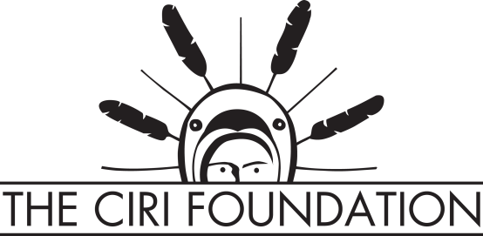

Pre-program Artist evaluation survey

Please take some time to complete this brief survey. The information collected in this survey is requested by The CIRI Foundation (TCF) and a national arts funding organization. It will be used to assess the diversity of art practices in Alaska and funding needs within the state. Your responses are voluntary.

Artist name: __________________________________________________

Age: _________________________________________________________

Current zip code: _______________________________________________

Home community: ______________________________________________

Cultural affiliation: ______________________________________________

Artistic skills: __________________________________________________

- How do you think your peers and community would rate your level of artistic skill?
- Novice
- Beginner
- Intermediate
- Advanced
- Expert

- How do you think your peers and community would rate your knowledge of cultural arts?
- Novice
- Beginner
- Intermediate
- Advanced
- Expert

- Do you make arts and crafts as a form of income?
o Yes
o No

If you answered yes, which of the following is more accurate for you?
- Sales of arts and crafts are a supplement to other forms of income
- Sales of arts and crafts are a primary source of income

If you answered no, are you interested in gaining tools to help you make an income from your work?
o Yes
o No

- How satisfied are you with the arts and crafts market?
- Very satisfied
- Somewhat satisfied
- Neutral
- Somewhat unsatisfied
- Very unsatisfied

- Level of business and marketing skills
- Novice
- Beginner
- Intermediate
- Advanced
- Expert

- Do you make Alaska Native arts and crafts to use within your community and/or family?
o Yes
o No

- From the list below, please mark all of the reasons why you engage in your artistic practice:
- Recreational/personal enjoyment
- Kinship
- Community development
- Cultural preservation
- Cultural identity
- Cultural revitalization
- Other______________________________

Thank you for completing this survey.

